White, Bernard John (Barney) (based mainly on Roger Underwood (2006) “Old Growth Foresters. The lives and times of West Australian Foresters”)
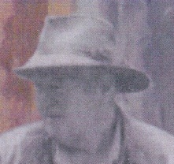
Graduated from Australian Forestry School in 1948. First appointment with Forests Department was at Shannon River c1949. Divisional Forest Officer Shannon River in 1958-62, taking over from Phil Shedley. Divisional Forest Officer Pemberton 1962-65, then worked in Manjimup Research Branch on karri silviculture. Moved to Perth c1970. Transferred from Extension to Como Research and extension work in 1974. When CALM was formed, he was appointed Regional Manager of Perth Metropolitan Region. After 2 years in that position, he retired in 1987 and moved to Meelup. Died 2000.

